Chapter X Hydration and Microstructural development.

Introduction
There has been great progress in understanding hydration mechanisms in the past 20 years. Unfortunately, most text books, even those recently published, have not taken recent work into account and reiterate ideas that are not at all compatible with the experimental evidence. In this chapter, we try to give an overview of the hydration mechanisms, which are emerging from recent work and identify areas in which there are still open questions. At the end of the chapter, we recap some of the most entrenched myths about cement hydration.
The first part of the chapter focusses on the hydration of alite, which is the most important phase in cement, as it is the most abundant and also the phase contributing the most to the development of properties, particularly at early age. Next, the hydration C3A with calcium sulfate, both alone and in cement is presented. After, we look at the whole cementitious system – including, the role played by belite and ferrite and discuss the important differences between microstructural development, between alite and cement.

General concepts
Hydration is the central process that transforms a fluid mixture of cement and water into a hardened material. It is now clear that hydration occurs by first the dissolution of the anhydrous cement in the pore solution, followed by the precipitation of hydrates. This is a so called “through solution” process, first proposed by the famous French chemist, Le Chatelier, more than 100 years ago. In the past hypotheses of solid-state reaction have been proposed, but the large differences in crystal structure (arrangements of atoms) between the reacting clinker phases and the hydrates mean that these are not tenable.
Because the water molecules are now part of the solid precipitates, there is a large increase in solid volume on hydration (roughly 2 times), which fills the spaces between the original cement grains and leads to setting and hardening. This essential change in the occupation of space is shown schematically in Figure 1. While the solid volume increases substantially. The overall volume decreases slightly (5-10%) as the average volume occupied by the water molecules in the hydrates is less than that in liquid water. This is true even in the case of reactions that are known to cause macroscopic expansion, such as the hydration of free lime or periclase. Box 1 shows the volume balances for some of the reactions occurring in cements.
Figure 1 schematic of hydration

Box 1: volume balances for some of the hydration reactions in cements

Thermodynamic hydrate assemblages (here or previous chapter)
Because the reaction occurs through solution , the hydrates which form can be well predicted by thermodynamic modelling of the precipitation of the most saturated phases from aqueous solution

Overview of reaction kinetics (Alite)
Impure C3S or alite makes up around half to two thirds of Portland cement. Its hydration dominates the setting and strength development. For this reason, we will focus first on the reaction mechanisms of this phase.
The overall reaction can be monitored by the evolution of heat. This is typically done in an isothermal conduction calorimeter. A typical heat evolution curve for alite is shown in Figure 2. Initially there is a burst of heat evolution, but quickly the rate of reaction dies down, before increasing again after a few hours. This period of low reaction rate is known as the induction period. The term dormant period is also sometimes used, but this implies that nothing is happening, which is certainly not the case. The induction period is of great practical importance as it provides a period of time during which the cement is fluid and can be transported and put in place before setting occurs.
Figure 2 Heat evolution curve, show differential to one day and cumulative on log scale after
At the end of the induction period the rate of reaction increases to a maximum at around 10 hours before decreasing again, giving what is often known as the main heat evolution peak. After the main heat peak, from around one day, the rate of reaction slows continuously. The heat evolution has been divided into as many as 6 different periods. Here the mechanisms will be discussed for three broader periods as indicated by the different shaded areas in Figure 2.

Period I: Up to the end of the induction period.

The reasons for the induction period have been one of the most intensely researched and debated topics in cement chemistry. The viewpoint widely put forward in texts is that the reaction slows down due to the formation of an inhibiting layer of some kind. This is analogous to passivating oxide layers that form on the surface of some metals, which slow down corrosion rates. However, research in recent years has shown that this is most certainly not the case and the slowdown in reaction rate is simply due the build-up of ions in solution decreasing the undersaturation.

Why are theories involving an inhibiting layer incorrect?
Before looking at the real mechanism behind the induction period, it is useful to underline why inhibiting layer theories are not correct.
We cannot see it: At the time most inhibiting layer theories were proposed, analytical techniques, in particular electron microscopy, were not as advanced as now. Consequently, it may be regarded as acceptable to invoke a layer that could not be observed directly. Now we have a range of imaging methods with resolutions down to near atomic dimensions so we really would expect to be able to observed an inhibiting layer, if it existed. On the contrary, several high resolution techniques clearly show no layer formation. Figure 4 shows the surface of an alite grain after x minutes. Isolated precipitates of C-S-H can be seen on the surface, but these are not a continuous layer. Between these isolated precipitates etch pits can be seen on the surface a few nanometers in size. The image on the right of the figure comes from a cement paste a few hours old (around the end of the induction period), but is particularly interesting as it was taken in a cryo scanning electron microscope. With this technique the paste is rapidly frozen and then fractured. The frozen water is then evaporated by sublimation and the freshly fractured surface is placed into the microscope. In this image an alite grain has been broken so the surface can be seen in cross section. Scatted hydrates of C-S-H are visible, which have grown from the first precipitates seen in the left-hand image. But again, these clearly do not cover the surface. The fracture has passed through several etch pits and it is clear that there is no layer covering these. Many other images from much earlier hydration times, such as Figure 5: 5 minutes after the addition of water, show similar features – a surface mainly clear of hydrates.
Figure 4 early picture from Amelie of surface after a few minutes with scattered hydrates plus nicoleau image
Figure 5. 5 minutes hydration elise or amelie
Large differences in atomistic structure of alite and C-S-H: Passivating oxide films that form on metals have very similar crystal structures to the underlying metal, so that they may form epitaxially by solid state reaction. For this reason, there is excellence adherence between the film and the metal and a high degree of impermeably. There is no such similarity between the structure of alite and C-S-H. For example, in alite the silicate tetrahedral are isolated, whereas in C-S-H they form chains, mostly dimers at early ages. C-S-H also has a layer structure with large amounts of water in the interlayer. Mention hydroxylated surface? Should I talk about the A and B curves of Jennings and Gartner
Experimental results impossible to explain: A number of experimental results are impossible to explain on the basis of inhibiting layer theories. These are discussed in more detail in the paper by Juilland et al listed in the further reading at the end of the chapter. One of the most inexplicably results is the effect of annealing alite on the hydration reaction shown in Figure 6. The solid curve shows the rate of heat evolution for freshly prepared alite, while the dotted curve shows the same alite hydrated after annealing for x hours at xx °C. After annealing the induction period is greatly extended. How could an inhibiting layer be forming with such different behaviour in the two cases?
Figure 6 calorimetry curves of annealed samples
However, the strongest evidence against the inhibiting layer theory is that there is an alternative hypothesis with a sound theoretical foundation, which can explain all experimental results.

The “geochemical” theory of dissolution
The dissolution of natural minerals has been extensively studied. Here there has also been much debate about the possible existence of inhibiting layers slowing down the initial dissolution rates. However, it is now generally accepted that the evolution of dissolution rates can be explained in a much more straightforward manner.
Many readers will have studied classic nucleation theory, such as in the solidification of metals; here it is well known that nucleation does not occur exactly at the equilibrium melting temperature, but that some degree of supercooling is needed before the first stable nuclei form. The supercooling is needed to provide energy for the formation of the interface between the solid and the liquid. In the same way, dissolution from a smooth surface requires energy for the formation of the extra surface left after the removal of the first material. In this case, the energy for the extra surface comes from the free energy difference between a solution in equilibrium saturation with the mineral and the actual solution composition – the undersaturation. For this reason, geochemists regard dissolution as negative growth, which is why in the diagram in Figure 7 undersaturation increases to the left and dissolution rate increases downwards
Figure 7, new figure similar to slides but trying to combine images and graph.
At high degrees of undersaturation, which is the case when a mineral is placed in contact with pure water, there is ample energy for the formation of new surface and a very rough surface develops with dissolution from many sites. As dissolution proceeds the undersaturation decreases due to the build-up of ions in solution. In less undersaturated solutions less energy is available to form new surfaces and dissolution becomes more localised at high-energy sites, such as dislocations, where etch pits form. As the undersaturation decreases further, there is no longer enough energy to form etch pits and dissolution proceeds slowly by step retreat. The transition from rapid dissolution at etch pits to slow dissolution by step retreat is quite pronounced and occurs when the concentration of ions in solution may still be quite far from equilibrium saturation.
Evidence for this pattern of dissolution is well established for a wide range of natural minerals. Logically alite, which is a synthetic mineral, would be expected to follow the same behaviour
Figure 8 pictures of Alite dissolution from Juilland
Figure 9 AFM pictures from di Murro
Figure 7 and Figure 8 show how the different dissolution regimes can be observed in the case of alite. In Figure 7 the surface of a freshly prepared alite is seen along with the same alite after immersion for 2 minutes in pure water (top) and in saturated calcium hydroxide solution (bottom). After immersion in pure water multiple etch pits are apparent on the surface of one of the alite crystal at the bottom left of the image. The very different dissolution of the two alite crystals indicates that crystallographic orientation plays a strong role in etch pit formation, probably due to the variation of surface energy with orientation and the configuration of dislocations. In the case of the sample immersed in saturated lime solution, there is almost no evidence of dissolution. Figure 9 shows a series of image taken in-situ from an area undergoing dissolution taken in an atomic force microscope (AFM), equipped with a wet cell. At first, a rough area forms in the centre of the image. Later a series of steps form on the upper right of the images that clearly move over time.
Figure 10 dissolution rates experimental from ICCC paper
Figure 10 shows how the dissolution rate of alite varies with solution concentration. For ionic activity products of 10⁻⁷⁰ and less, the dissolution rate is almost constant. The shaded box, shows the range of concentration expected in the presence of solid calcium hydroxide.

Why does the induction period end
Calcium silicate hydrate precipitates very early, small precipitates can be seen after only a few minutes (Figure 4) and studies in solution also indicate a first precipitation event within the first 5 minutes. As the calcium silicate hydrates precipitated have a lower calcium to silicon ratio than 3, the calcium concentration in solution increases and the silica in solution decreases. This is illustrated by the data from Brown et al shown in Figure 11. The calcium concentration reaches a peak at the end of the induction period, which is about 1.3-1.5 times higher than the equilibrium solubility of calcium hydroxide
Figure 11 changes in solution concentration in a paste of C3S at w/c = 0.7
The end of the induction period in pastes is marked by the precipitation of calcium hydroxide, this leads to a decrease in the calcium concentration in solution and therefore an increase in the undersaturation of C3S, such that the dissolution rate can increase again. As seen in Figure 10, the dissolution rates in the range of concentrations expected in the presence of solid calcium hydroxide, varies by an order of magnitude. At the same time, a distinct change in the growth morphology of C-S-H occurs as illustrated in Figure 12. It is not clear which of these two phenomena is the rate determining step and both are probably connected. Experiments in solution with controlled concentration such that calcium hydroxide does not precipitate, also show an upturn in the rate of reaction. And seeding experiments with C-S-H dramatically shorten the induction period. These observations favour the change in growth morphology as the trigger for the acceleration period.

Figure 12. Change in growth morphology of C-S-H which occurs at the end of the induction period. a) 40 minutes; b) 2 hours (just at the upturn of the acceleration period; c) 4 hours

Main hydration peak
The main hydration peak is characterised by the growth of C-S-H on the surface of the C₃S grains (and indeed on any available surface). This is accompanied by the precipitation and growth of calcium hydroxide, which appears to take place in the pore spaces as far from the hydrating grains as possible. The mechanisms controlling the kinetics in this period have been the subject of much discussion. Many workers have looked at the applicability of the Avrami equation or Johnson-Mehl-Avrami-Kolmogorov (JMAK) equation; where the degree of reaction at time t is given by: α(t)=1-exp(-Kt^{n}). This was derived to describe the kinetics of phase transformation, such as the solidification of the metal and is illustrated schematically in Figure 13. Nuclei are assumed to form randomly throughout the original phase (e.g. liquid); they start to grow and the growth rate is proportional to their surface area. When the growing precipitates start to impinge on each other the surface available for growth decreases and so the rate of reaction. This gives kinetics with a classic peak in reaction rate as shown in Figure 14, or a classic “s” shaped curve in terms of cumulative reaction. For this reason, the JMAK equation can be easily fitted to the kinetics of cement hydration. However, it is found that the parameters K and n vary widely from one cement to another in an unpredictable way and cannot be related to physical parameters.
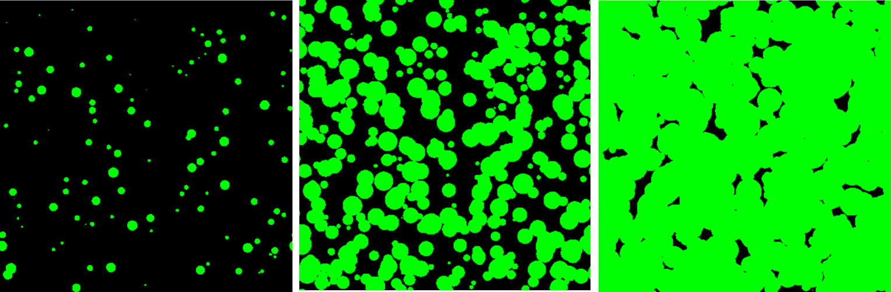
Figure 13: Schematic of phase transformation behind the Avrami equation.
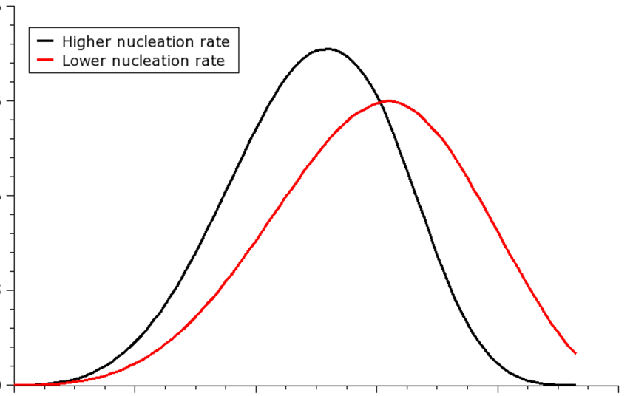
Figure 14. Reaction kinetics from Avrami equation.
To take account of the fact that C-S-H grows on the surface of particles. Boundary nucleation and growth (BNG) models were developed, where the nuclei are confined to form on surfaces. The parameters in these supposedly have a physical meaning, such as growth rate. However, these parameters still need to be changed between systems to fit the experimental data, even with systems where one would expect them to be constant, such as the same alite ground to different particle sizes.
Further insights can be obtained from microstructural models, which explicitly visualise the individual particle. These can take into account the wide range of particle sizes encountered in real cementitious systems. This is important as cement grains typically range from several tens of microns down to less than a micron in size, and a 100 µm sided box will contain several millions of particles. Such models indicate that simulation of C-S-H growth on the grain surface fits well the experimental data up to the peak. However at the peak there is very little overlap between precipitates growing from one particle with those growing from another, so that the rate of reaction continues near constant and does not slow down as observed experimentally.
The slowdown in the reaction rate after the peak is often considered to be because diffusion through a hydrate layer around the grain becomes the rate limiting step. However, there is now a wealth of evidence against this:
- First, careful study of micrographs at the peak indicate that the surface of the alite grain is still visible in places, so there is no continuous layer. Micrographs also show that gaps develop between the hydrating shell and the reacting anhydrous grain, which are largest around the end of the main heat evolution peak. If the shell were a diffusion barrier, such gaps would not be expected to form.
- Secondly, when simulations of a post peak diffusion mechanism are made for different sizes of alite it is found that the “diffusion coefficient” needed to “fit” the data vary by an order of magnitude. Considering, that the alite is exactly the same and that C-S-H forms through solution, there can be no reason for this variation.
- Thirdly, experiments at different temperatures show that the kinetics scale according to the Arrhenius law with a single activation energy (~xxkJ/mol). Chemical processes involving bond breaking or formation generally have relatively high activation energies (>40 kJ/mol). In contrast transport processes, i.e. diffusion have lower activation energies (~20 kJ/mol).

So, if neither growth impingement nor diffusion explain the slowdown, what is causing the deceleration period? New evidence has come from the study of alite doped with zinc. As shown in Figure 15 the introduction of zinc in solid solution dramatically increases the height of the main hydration peak. Study of the materials by TEM, shows that the C-S-H needles in the case of the zinc doped alite are much longer than those in the case of the pure C3S. This leads to the hypothesis (that C-S-H needles grow from the surface to a certain length and then stop growing. During the acceleration period, needles grow and more form until the surface of the alite grain is mostly covered. The rate of the reaction then slows as the needles attain their maximum length and as the there is less and less space for more needles to grow from the surface.

Figure 15 Heat evolution curves for pure C3S and C3S doped with x% zinc, with TEM and graph of needle length
Figure 16 Hypothesis of growth of needles to maximum length

This hypothesis has now been validated quantitatively, taking all the parameters from experimental observations. The same experimental parameters can be used to model the hydration kinetics for different particle sizes of alite, different water to cement ratios and alites with different dopants. Figure? The question now arises as to why the C-S-H needles only grow to a certain length. This is not yet fully understood. However ongoing research with population balance modelling, suggests that secondary nucleation (on primary nuclei) plays an important role in C-S-H growth. It may also be related to the poorly crystalline nature of C-S-H discussed in the previous chapter. Once a certain amount of distortion and defects is reached, grow is inhibited.

Link between growth rate and solution concentration
During the discussion of the induction period, it was explained that the rate of dissolution of C3S was controlled by the undersaturation of the solution. The

After the main hydration peak
After the main hydration peak there is a continuous slowing down in the rate of reaction. There has been relatively little study of the mechanisms controlling the reaction rate during this period, despite the fact that most of the development of strength and other properties occurs after one day: a typical cement paste or concrete will develop only about ¼ of its 28 day strength after one day. After the first day, it is important to consider the consumption of small grains. Figure 17, shows how the size of grains evolves during the main hydration peak. By 24 hours grains smaller than about 5 µm are completely hydrated. This poses a problem of using pure C3S as a model for cement hydration. The growth of grains during the solid state synthesis of C3S is very slow and generally limited to around 5-8 µm for typical synthesis conditions. This is in contrast to the situation in clinker production, where the presence of liquid leads to the growth of larger alite grains (typically around 20 µm) and alite crystals held together in even larger cement grains, by the liquid which solidifies to the interstitial phases: aluminate and ferrite.
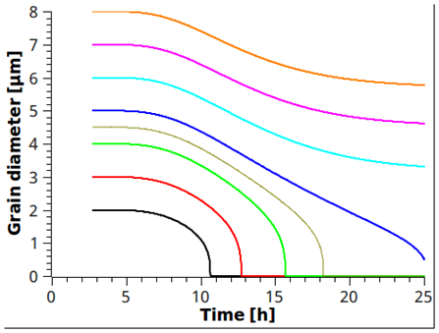
Figure 17size of grains remainng from alex
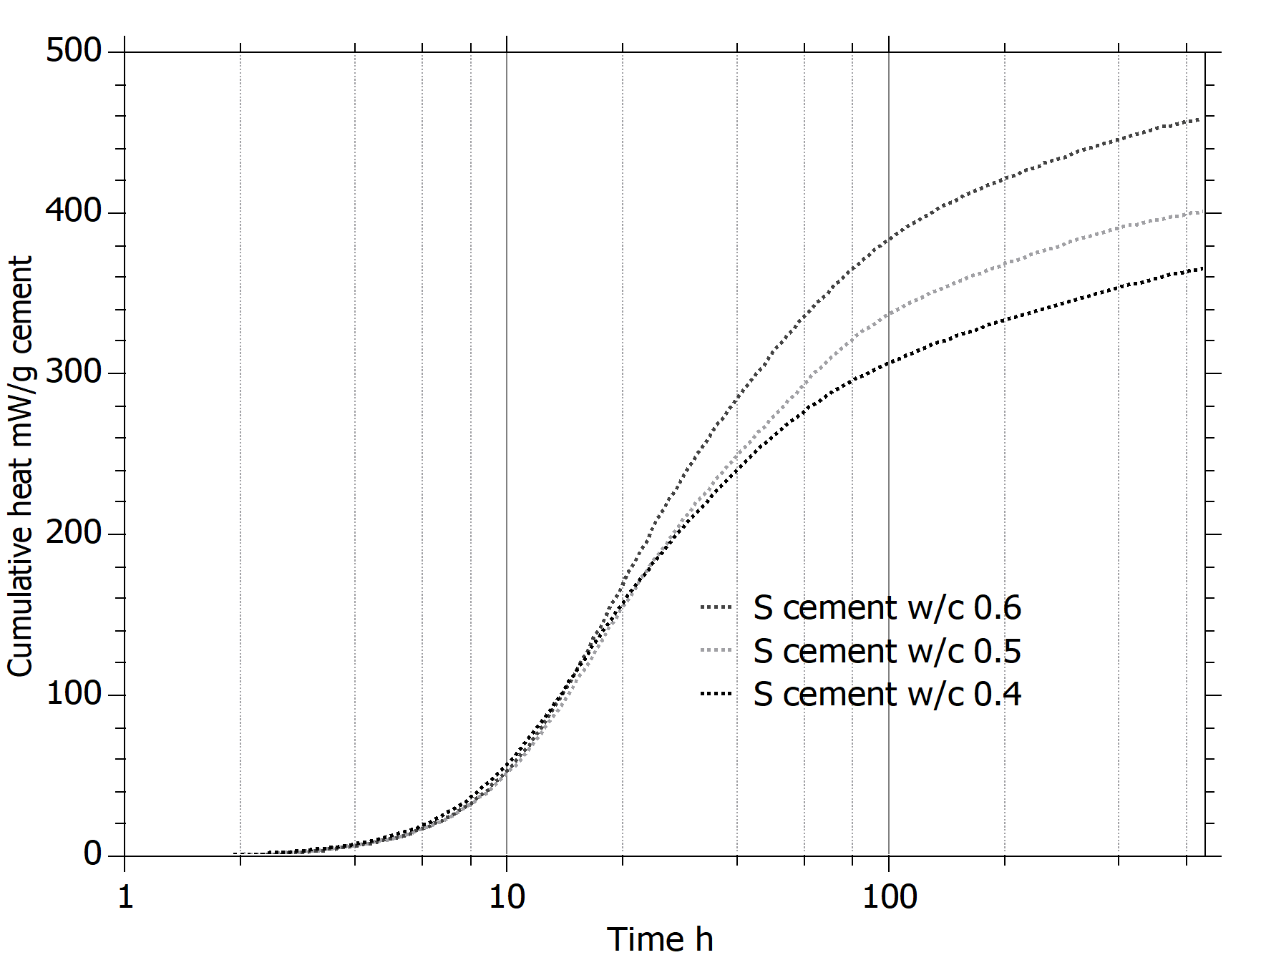
Figure 18. Impact of water to cement ratio on hydration
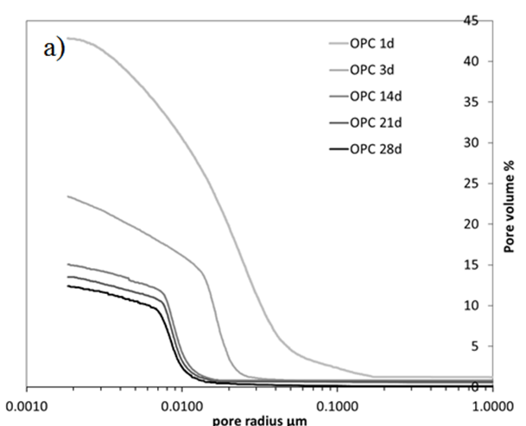
Figure 19 MIP curves and NMR results

After the first day, the water to cement ratio plays a major role in the ongoing rate and extent of hydration as illustrated in Figure 18. All the pastes are similar through the main hydration peak, corresponding here in the cumulative heat evolution to a slope, which ends at about 18 hours. From this point, the curves diverge until about 6 days, after which they evolve in parallel. The limitation of hydration is not due to lack of water as the experiments were carried out with excess water on top of the specimens and after 6 days the samples continue to hydrate with similar kinetics. Therefore, it is clear that from about 1 to 6 days (period IIIa in the figure) the reaction is mainly controlled by the space available for the hydrates to form. At the end of this period IIIa, mercury intrusion porosimetry (MIP) and proton NMR relaxometry reveal that a minimum size of the capillary pores has been reached. Figure 19 shows results from these techniques. MIP curves may be characterised by the critical pore size, which is the inflexion point on the steep rising part of the curve (or peak in the differentiated curve), this is the size of pores, which are connected through the specimen. It can be seen that this critical pore size decreases rapidly during the first few days, but from 6 days it remains constant at , even though the total amount of porosity continues to decrease. Similarly, the NMR results show the amount and size of the capillary pores decreases rapidly during the main heat evolutions peak, but after about X days even though the amount continues to decrease slowly, the average size of the remaining water filled pores stays constant. Scanning and Transmission electron microscopy Figure 21 indicate that from this point the vast majority of space between the original cement grains is filled with a mass of C-S-H fibrils and the connected capillary porosity is the spaces between these fibrils. For this reason we call them “interhydrate” pores. As seen in the SEM image, larger pores remain, notably the spaces within the small shells of hydrates left by the complete reaction of grains smaller than about 5µm during the main peak but these are only connected through the network of interhydrate pores. Another important feature during this period is the development of “inner” product, which forms in the space created by the dissolution of the anhydrous.
Figure 20 SEM and TEM micrographs of filled microstrucutre
Why should the lack of water filled pores above a certain size limit the hydration, even when considerable capillary porosity remains? To answer this question we need to consider the grow of a crystal into a small pore. Figure 21 illustrates this schematically. To grow into the smaller pore, the crystal need to increase its radius of curvature, this means that the concentration of the pore solution in equilibrium with the crystal increases and therefore, to grow the solution must have a higher concentration than this equilibrium. The supersaturation, (relative to an ideal crystal with no curvature) needs to increase. When the pores become too small the pore solution is no longer sufficiently saturated for “classical” growth to continue. While it is now clear that, the availability of space is controlling kinetics during several days after the end of the main heat evolution peak. We still need to establish a precise quantitative relationship between the rate of hydration and the space available.

Figure 21 schematic of growth into small pores
After the period of filling space the hydration appears to continue at roughly the same rate irrespective of water to cement ratio. However, this rate is considerably less than in the space filling regime and appears to decrease continuously. Part of this decrease in related to the deletion of anhydrous material. The degree of reaction of alite at 7 days may already be quite high. The mechanisms occurring here are not clear, but may be related to the densification of C-S-H.

Summary of alite hydration
The hydration of the main alite component may be separated into 4 main periods:
- In the first period, up to the end of the induction period, the dissolution of alite is the rate determining mechanism, controlled by the undersaturation of the solution. This ends with the precipitation of calcium hydroxide and perhaps a change in the growth morphology of the C-S-H.
- The second period, the main hydration peak is controlled by the growth of C-S-H from the surface of the anhydrous grains. The needles, fibrils or foils of C-S-H grow to a critical “length”. The limitation in the extent of growth and the coverage of the grains limits the hydration during this period.
- The third period is controlled by the filling of space by the outer hydrates. At the same time inner product forms in the space created by the reacted anhydrous phase.
- In the fourth period hydration continues at an ever decreasing rate. Densification of C-S-H and the continued thickening of the inner product play a role.

Hydration of aluminate phase
The aluminate phase, C3A is the other main clinker phase that contributes to early hydration. The reaction of C3A alone with water is very rapid, giving rapid stiffening of pastes, known as flash set. This results from the rapid precipitation of platy hydrates, C2AH8 and C4AH13
For this reason, calcium sulfate is added during grinding to control the aluminate reaction. There are several forms of calcium sulfate, containing different amounts of water in the crystal structure. The dihydrate form (CaSO4.2H2O) is gypsum. Natural gypsum usually contains some calcium sulfate anhydrite (CaSO4), which is dissolves more slowly. During grinding, partial dehydration of the gypsum to calcium sulfate hemihydrate (CaSO4.½H2O) (also known as plaster) may occur. Finally complete thermal dehydration of gypsum, without recystallisation gives another form of anhydrite, usually known as soluble anhydrite. The rate of dissolution of these different calcium sulfates decreases in the order:
Soluble anhydrite > hemihydrate > gypsum > natural anhydrite.
Usually a combination of these different calcium sulfates will be present, but it is important to have enough rapidly dissolving components to well control the early reactions of the aluminate and ferrite phases. Soluble alkali sulfate phases usually present in the clinker also contribute to the control of the aluminate reaction.
The presence of calcium sulfate completely changes the hydration reaction of the aluminate (and ferrite) phases. A typical heat evolution curve is shown in Figure X. Initially there is a rapid reaction with the formation of ettringite (equation x), but the rate of reaction quickly dies away and remains low during many hours. During this period ettringite continues to form slowly and eventually all the calcium sulfate is consumed so the length of this period depends on the amount of calcium sulfate relative to the amount of C3A.
C3A + C$H2 => C3A.3C$.H32
Or
Ca2+ + etc
When all the sulfate is consumed there is another period of rapid reaction with the formation of calcium aluminate monosulfate according to equation 2.
Many texts describe the reaction of the aluminate as being “blocked” by ettringite. Certainly, the presence of calcium sulfate changes the reaction product formed to ettringite. However, as can be seen in Figure 22, the small ettringite rods formed in solution in no sense form a barrier around the grains. Although full details of the mechanism are not established, it seems that sulfate ions absorb on the surface of the aluminate and ferrite phases and inhibit their dissolution.
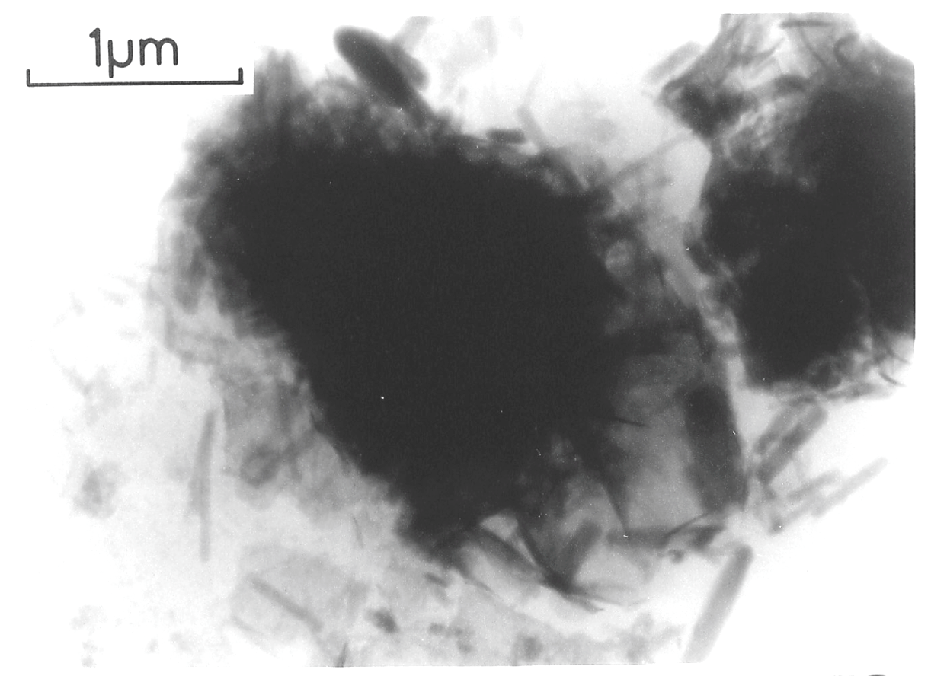
Figure 22 early ettringite reaction

This control of aluminate dissolution is critical to allow the alite phase to react properly as high concentrations of aluminum ions in solution inhibit the reaction of alite. This is illustrated in Figure 23, which shows the impact of calcium sulfate in a model clinker of x%alite / y% C3A. For 2% and 2.6% gypsum addition the system is definitely undersulfated with a strong peak from the aluminate reaction (A_{u}) occurring before the silicate peak (S_{u}). Despite being undersulfated these systems do not show flash set, having an working time of a few hours before the alumina peaks. The systems with 3.3, 4.1 and 5% gypsum are all properly sulphated as the aluminate peak occurs after the silicate peak. As the aluminate reaction occurs later at high sulfate additions it becomes lower and broader, however, the total amount of reaction is similar.
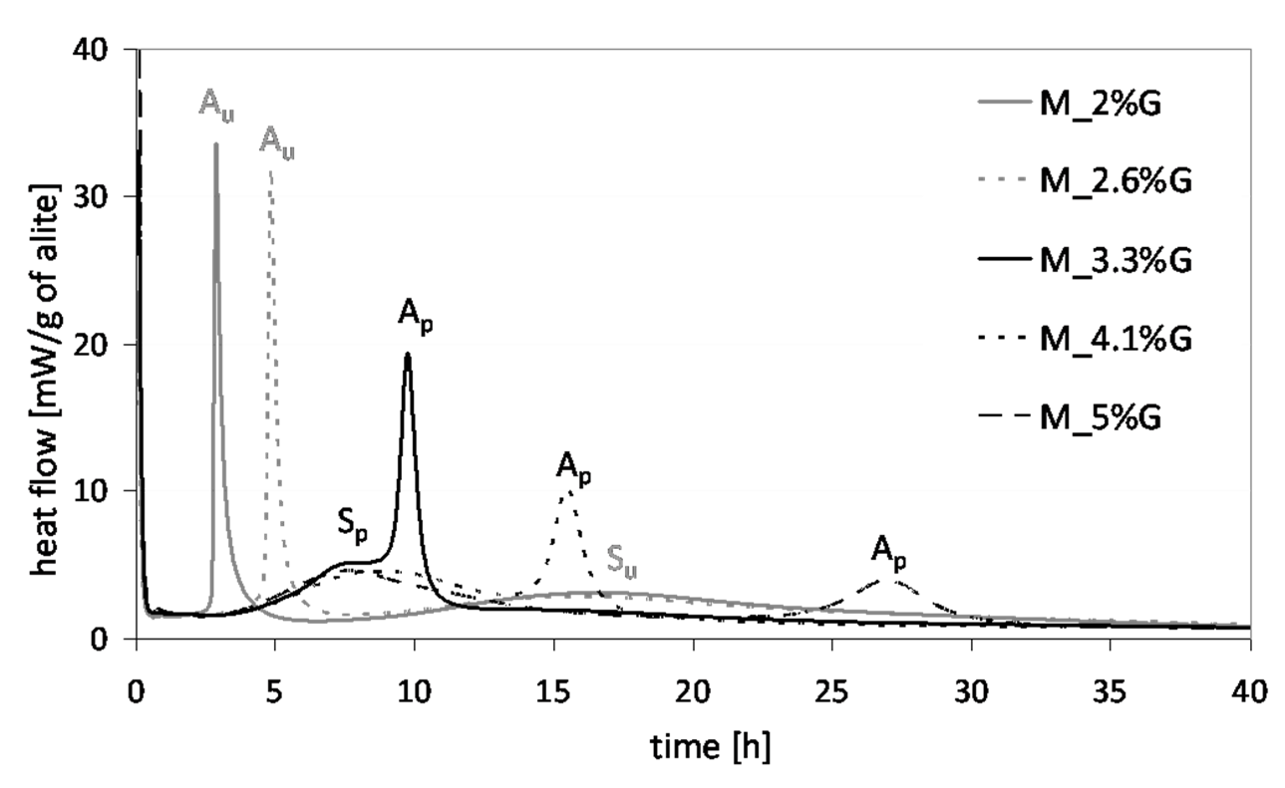
Figure 23 Impact of sulphate addition in an alite C3A system
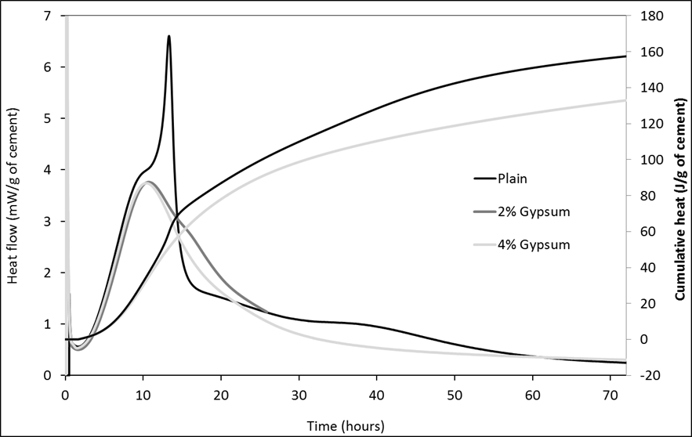
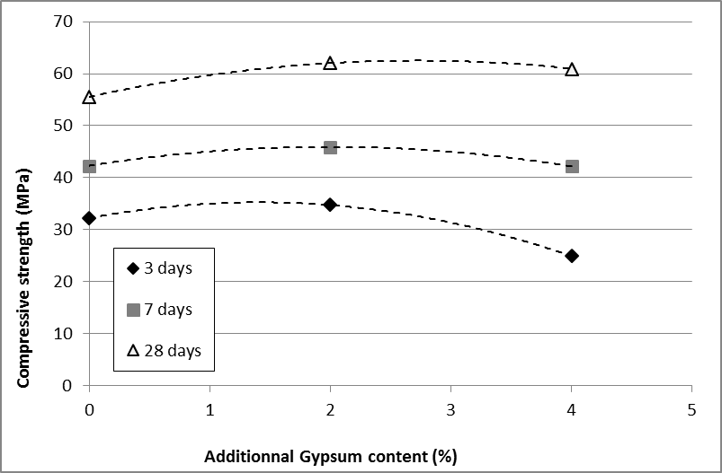
Figure 24 Impact of sulfate on strength
Figure 24 shows the impact of sulfate level in a commercial white cement on the hydration kinetics and strength development. At the lowest level of sulfate addition the cement is on the edge of being properly sulphated as the aluminate peak occurs just after the silicate peak and the aluminate reaction clearly suppresses the reaction of silicate after 15 hours. When the sulfate addition is on the limit, like this, the proper sequence of reactions may be destabilised by the presence of admixtures or mineral additions. At 3% sulfate addition the hydration curve becomes more “normal” with a shoulder peak from the aluminate reaction on during the deceleration part of the silicate peak. At a sulfate level of 3.8% there is no clear aluminate peak within the 72 hours the hydration was followed. The consequences for the strength are shown in the accompanying figure. This demonstrates that there is and “optimum sulfate” from the point of view of strength development. Which is higher than the level necessary merely to control flash setting.
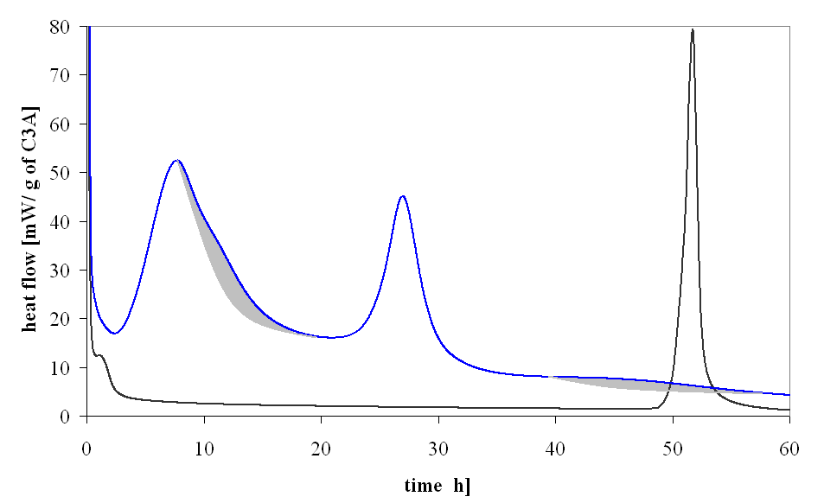
Figure 25 alite aluminate gypsum curves from Alexandra
When C3A is hydrated in a cement, in parallel with the reaction of calcium silicates the reaction sequence is also complicated by the absorption of sulfate on C-S-H. Figure 25, compares the heat evolution curves for C3A hydrates with 40% Gypsum and for a model cement 87% alite, 8% C3A and 5% gypsum – i.e. the ratio of gypsum to C3A is the same in both cases. In the case of C3A and gypsum alone the monosulfate reaction starts around 50 hours. In the model cement there are now 3 peaks associated to the aluminate reaction: A1, A2, A3. A2 corresponds to the formation of monosulfate and the onset of this reaction now occurs after only about 25 hours. The shoulder peak A1 corresponds to the aluminate reaction seen in most commercial cements. Studies by microscopy X-ray diffraction show that this peak is associated with the formation of long ettringite needles. Both these changes are related to the absorption of sulfate ions on C-S-H. The amount of sulfate ions absorbed on C-S-H is a function of the sulfate concentration in solution. With solid gypsum remains, the concentration of sulfate ions in solution is relatively high. Once all the solid gypsum has dissolved the consumption of sulfate due to ettringite formation leads to a drop in the sulfate concentration in solution and sulfate ions desorb from the C-S-H these desorbing ions are then available to form more ettringite, as seem in the micrograph. The X-ray diffraction data in Figure 26 also show that both the A2 and A3 peaks correspond to the formation of monosulfate, but it is not clear why this reaction now occurs in two steps.
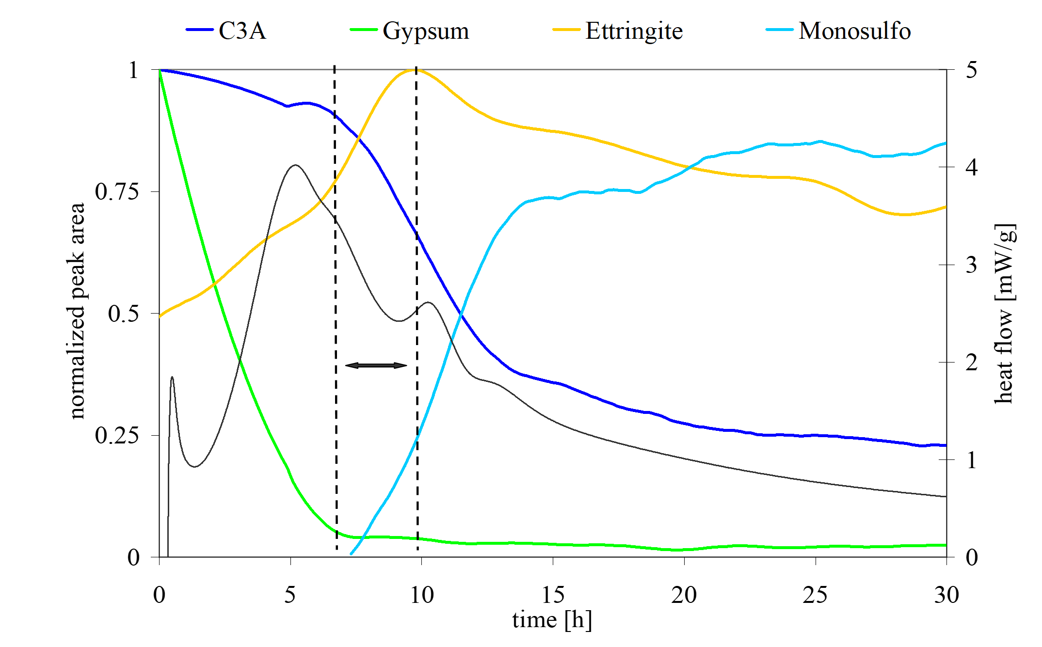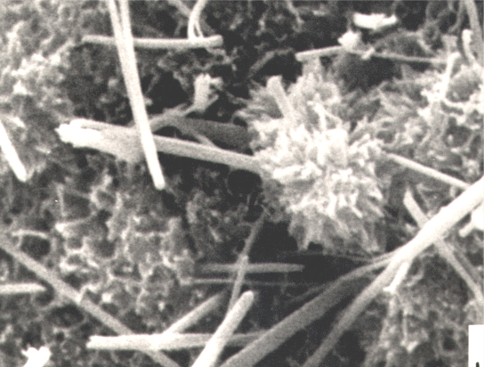
Figure 26

Reaction of the different clinker phases in real cements .

Before looking in more detail at the reactions of the belite and ferrite phases it is useful to compare the rates of reaction of the four main clinker phases in typical cements, Figure 27. Around 50% of alite has reacted at one day and around 90% by 28 days. In contrast there is no significant reaction of belite for around 10 days and after one year the degree of reaction is still only around 50%. It appears that the reaction of belite is inhibited by the presence of reacting alite. Even in very old concrete unreacted grains of belite can be clearly seen, Figure 28. The reaction of belite grains is often very uneven. During cooling of the clinker the polymorphic transformation of these phase lead to segregation of impurities along twin boundaries, which makes some parts more reactive than others.
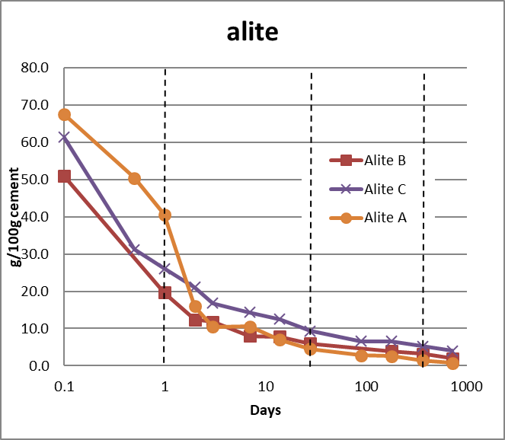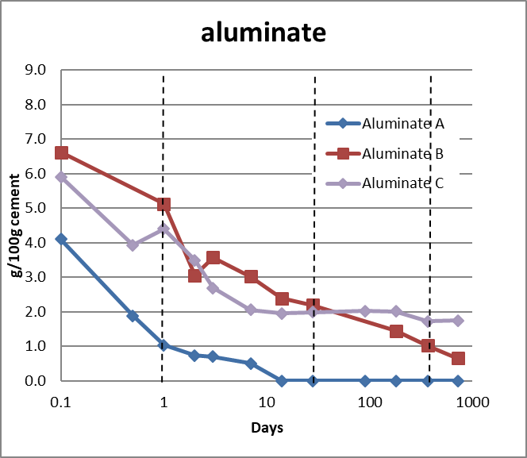
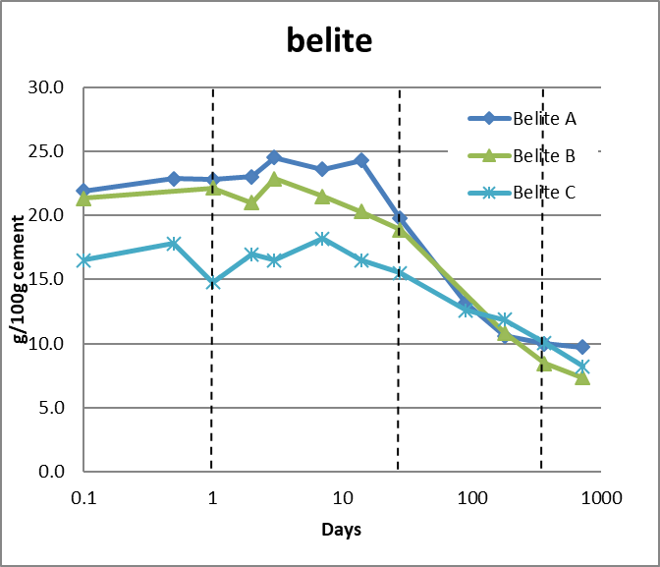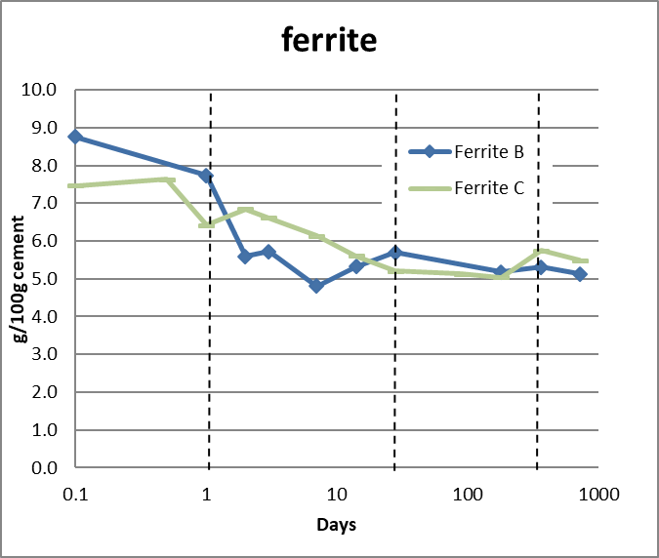

Figure 27. Degree of reaction of the four main clinker phases over time for 3 commercial cements (as A is a white cement there is no ferrite phase)
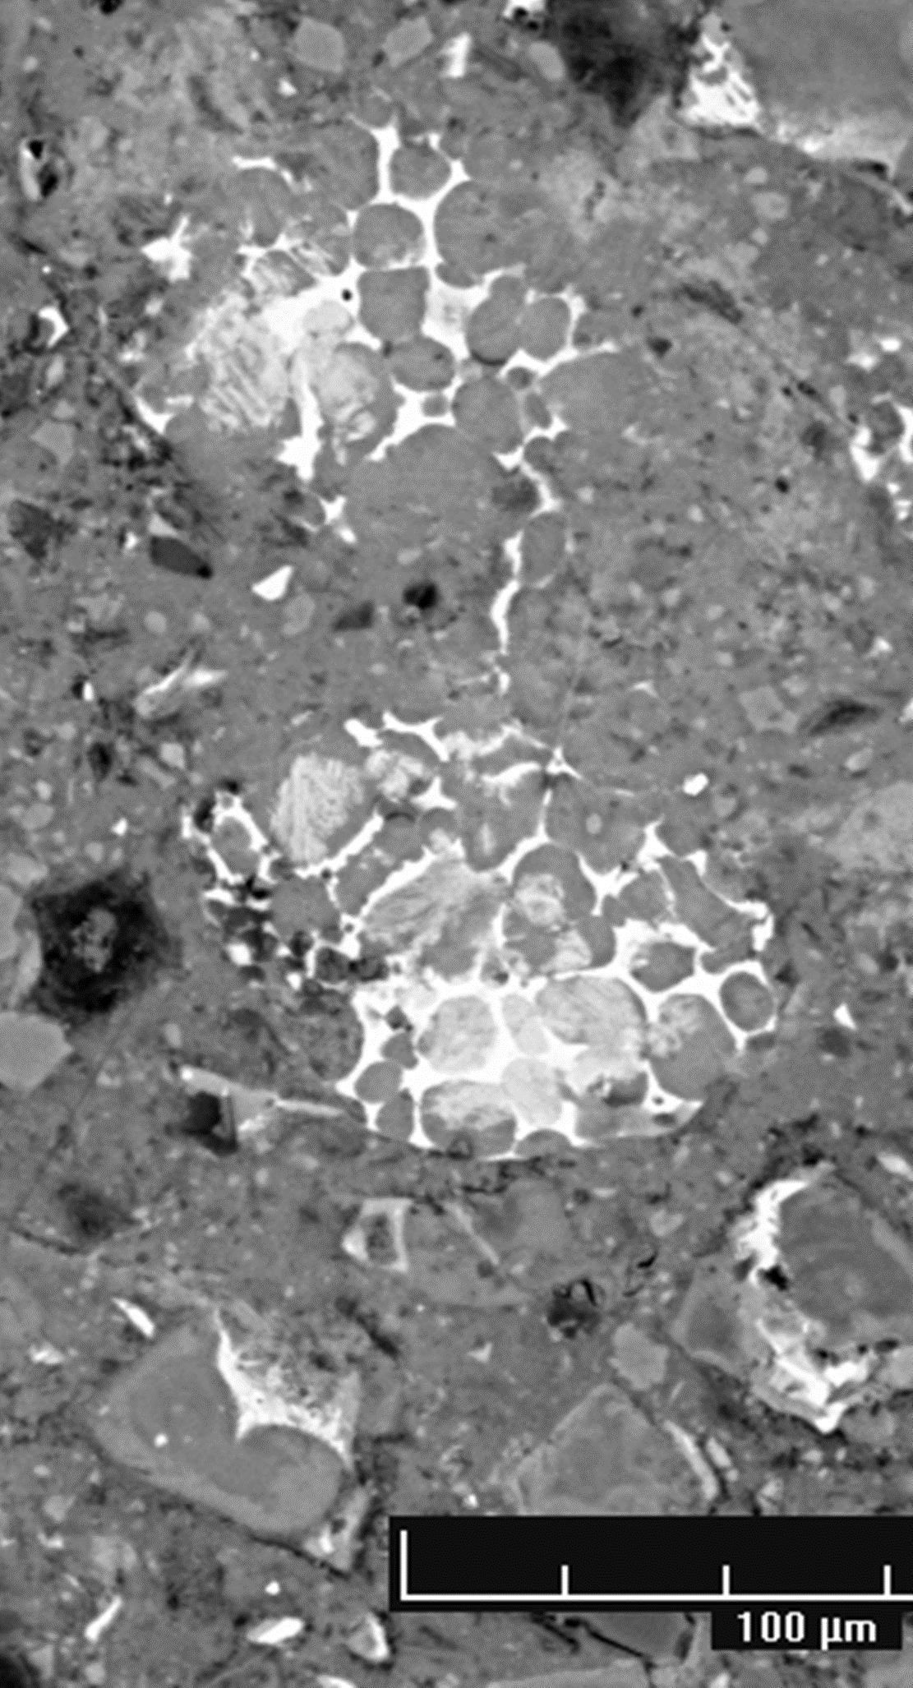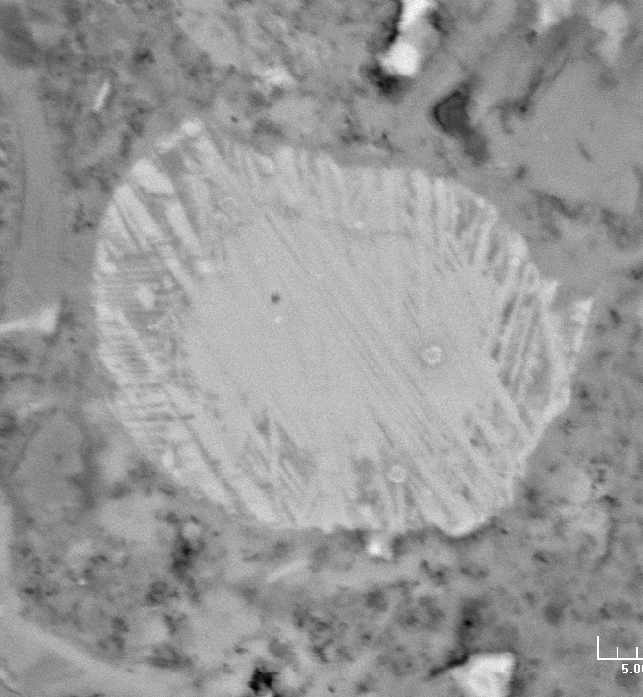
Figure 28. Image from 30 year old concrete, left, showing unreacted belite particles. The reaction of belite is often very heterogeneous as shown right. The striations arise from the polymorphic transformation of belite during cooling, which lead to multiple twinning and segregation of impurities. This makes some parts more reactive than others.
The degree of reaction of the aluminate phase is around 40% at one day for the grey cements and 75% at 28days. For the white cement the degree of reaction is already 75% at one day. These differences are explained by the intimate intermixing of the aluminate and ferrite phases, which solidify from the liquid phase during cooling of the clinker. The slow reaction of the ferrite phase limits the exposure of aluminate phase to the solution. Nevertheless, there is significant reaction of about 25% of the Ferrite phase at one day, increasing slowly to about 40% by 28 days. Despite this significant reaction in old concrete, e.g. Figure 28, the areas of ferrite appear, unreacted, but more detailed study with contrast adjustment shows that in the bright zones, there is a layer of reaction product surrounding remaining un reacted material,
Figure 29. Partially reacted ferrite phase in OPC hydrated for 2 years at. The bright zones are unreacted, but these are surrounded by a layer of reaction product which is a siliceous hydrogarnet

Points to mention
Overall microstructure and phase composition, thermodynamic modelling mass balance.
Impact of fillers
Effect of alkali and sulfate
Effect of temperature.

